Minerva M832B  sewing machine | 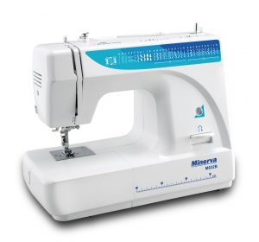 | Oscillating Hook | Zipper Foot
 |  | 3 Regulating Dials | Spool Pin Felt (2X)
 |  | Vertical Front-load Bobbin System | Pack Of Needles (3X)
 |  | Vertical Spool Pin | Oil Bottle
 |  | Four Step Buttonhole | L-Screwdriver
 |  | Threader Cutter | Edge/ Quilting guide
 |  | Presser Foot Pressure | Darning Plate
 |  | With Darning Plate For Embroidery | Buttonhole Foot
 |  | Built-In stitches: 32 | Button Sewing Foot
 |  | Adjustable Stitch Length 0-4.0mm | Brush/ Seam Ripper
 |  | Adjustable Stitch Width 0-5.0mm | Bobbin (3X)
 |  | Built-In Tension With Accurate Setting | All Purpose Foot
 |  | Automatic Bobbin Winder
 |  | Easy Slide Reverse Lever
 |  | Fold Away Carrying Handle
 |  | Free Arm Light Weight
 |  | One Touch Snap-on Foot
 |  | Strong Torque For Heavy Fabric
 |  | Automatic Needle Threader
 |  | Sewing speed: 800rpm.
 |  | Soft Cover
 |  | Country of origin: China

